21 July 2016
NEWSLETTER
Compiled by Shannon Dowdall of IDACA
Greetings to you from Ida Cooper Associates in Cape Town. We’d like to give you a few of the highlights of the first semester 2016 SSA students.

The last of our first semester 2016 SSA students left on June 27th and we welcomed the second semester group on July 9th.
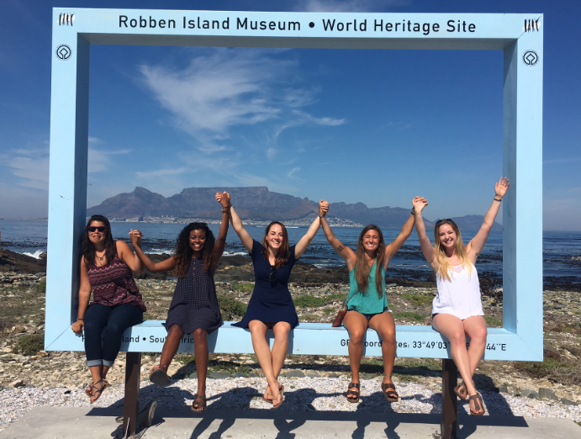

The first semester group arrived in the middle of summer in Cape Town at its best. They also arrived on a UCT campus that was still experiencing some protest action by a small group of students associated with the # FeesMustFall group. However, registration went without hitch and the debate and discussion around this issue generated engagement both with UCT students as well as with the wider Cape Town community and nationally in the media.

First semester students had a week between registering and when classes started which was a great time for them to explore Cape Town and for some to travel up the Garden Route along the east coast.

Academically, from feedback received, the SSA students enjoyed their courses appreciating the new perspectives and content. Courses they studied ranged from isiXhosa and History of African Music, Anthropology and African literature to Marine and Environmental Sciences as well as Business Science courses. Havilliah Malsbury (UC Merced) was adventurous enough to travel alone to a small village in the Eastern Cape to live with a female- headed family to improve his isiXhosa. He ploughed fields and herded cattle, sleeping in a hut with the children of the family (an experience his professor of isiXhosa assisted him in setting up). Henry Ascencio (UC Berkeley) followed up on his interest in animals and explored the immensely varied natural environment of the country.

Some of the students engaged in community service through UCT’s student –run SHAWCO organization. This involved tutoring school children of varying ages in the townships. They found this a rewarding and the experience broadened their understanding of the broader and varied Cape Town community.
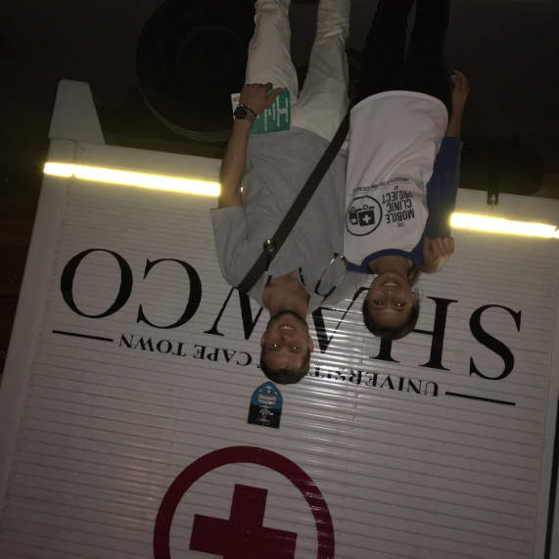

Culturally, they visited places of historical interest like Robben Island, the District Six Museum, attended services at St George’s Cathedral with Desmond Tutu and went to book launch interviews with authors who had been involved in the Apartheid struggle. Some of them travelled to the Afrika Burn Festival in the Tankwa Karoo area, a semi-desert area six hours from Cape Town. The festival required careful planning for the extremely cold nights and hot days without any form of electricity, running water and mobile reception. Amber Zeise (UC Berkeley) made contact with and participated in work in Cape Town with the Danish alternative business school KaosPilot. Princeton students accompanied Professor Francis Wilson on a four- day trip to Hogsback in the Eastern Cape.

They all explored the melting pot of the music, theatre, food and general festivities on offer during summers in Cape Town, eating in places from township “braais” to high- end restaurants rated amongst the Top 50 in the world. Most of the students made full use of the opportunities to hike the mountains surrounding the city, the coastal hikes in the Cape Point Nature Reserve, camp while travelling up the west coast towards Namibia and explore the winelands an hour outside of the city. Some learned to surf, went shark-cage diving, bungee jumping and rock-climbing.
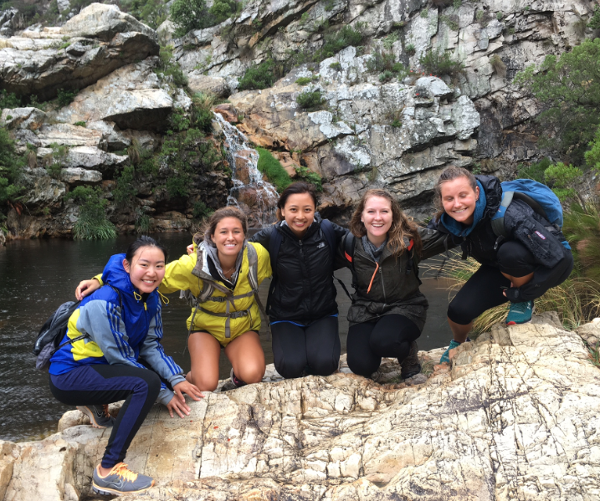

UCT’s Mountain and Ski Club was a popular club and students went off on weekend trails and hikes. The soccer and gymnastics clubs at were also popular clubs as a means of keeping fit and meeting local students. Where students indicated to us their specific interests, we were able to link them up with academics in those fields, such as Professor Vanessa Watson, School of Architecture, Planning and Geomatics and one of the founding members of the Centre for African Cities at UCT, doctors working in Public Health at Groote Schuur Hospital, the public and academic hospital in Cape Town as well as various NPO’s operating in Cape Town .Betty Nguyen (UC Los Angeles) work-shadowed a young doctor operating at the newest public hospital in the huge area of Mitchell’s Plain, known for its good design and “green” approach to its operations. Nicholas Martinez (UC Santa Cruz) wrote for “Varsity” the UCT student newspaper.
Most of them travelled widely throughout Africa as far Mali, where Adam Hanne (UC Santa Cruz) connected with family in Bamako. Ava Hoffman (Princeton) and Amber Zeise (UC Berkeley) travelled to Tanzania. Esther Maddox and Charlesa Redmond (Princeton) spent time in Mozambique. Many of them travelled north- west to the Cedarberg Mountains famous for their rock-art paintings and then further as far as Namibia, Botswana and Victoria Falls.
Fortunately no one experienced illness of a serious nature and those who had minor illnesses recovered quickly. There were two reported incidences related to crime but fortunately no one was hurt or injured.
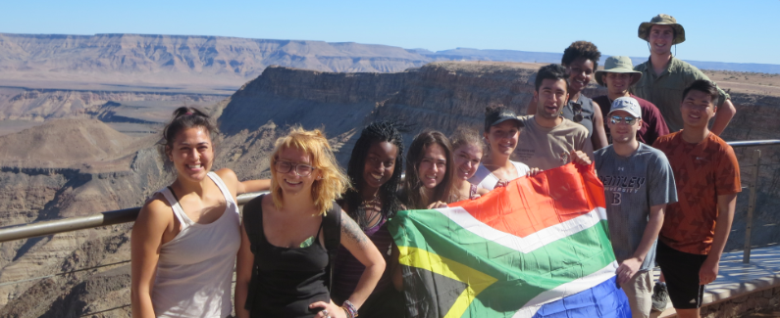

A number of parents and siblings visited the students in Cape Town, some exploring Cape Town and some going further afield especially to the Kruger National Park. We were fortunate to meet some of this wonderful diverse group of parents, supportive of their children and open to their experiencing a wider world different in many ways from their own.
We believe that it was a very successful semester. At the farewell dinner we hosted, they seemed to be a happy and cohesive group. In the words of one, “I’ve done more during this six months than in the rest of my life. I need to go home, keeping this momentum of exploring, exercising, being open to new ideas and working hard towards my goal of post-grad study. I definitely plan to return.”
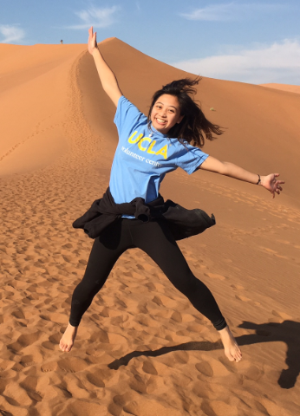

Classes have already begun for the second semester and although it is winter in Cape Town, the first two weeks were fine enough to explore Cape Town.

We appreciate and thank you for your continued support.
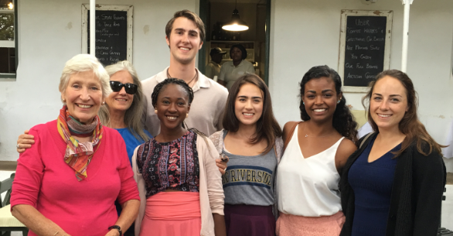

http://idaca.co.za
idacasouthafrica@gmail.com

